File number: ________

In the Supreme Court of CANADA
(On Appeal from THE Federal Court Of Appeal)

between:

RADU HOCIUNG

Applicant
(Appellant)
and

MINISTER OF PUBLIC SAFETY AND EMERGENCY PREPAREDNESS

Respondent
(Respondent)
APPLICATION FOR LEAVE TO APPEAL

Radu Hociung – Applicant
246 Southwood Drive, Kitchener, ON N2E 2B1
Tel: (519) 883-8454
Fax: (226) 336-8327
Email: radu.sc@ohmi.org

Minister of Public Safety and Emergency Preparedness,

Eric Peterson - Counsel to the Respondent
Department of Justice
Ontario Regional Office
120 Adelaide Street West
Suite #400
Toronto, Ontario M5H 1T1
Tel: 647-256-7550
Fax: (416) 973-5004
Email: eric.peterson@justice.gc.ca

Table of Contents
NOTICE OF APPLICATION FOR LEAVE TO APPEAL 3
1.Judgment and Reasons – Federal Court – T-1450-15 Summary Motion- Mar 16, 2018 5
2.Reasons for Judgment – Federal Court of Appeal – A-102-18 -– August 7, 2019 34
3.Judgment – Federal Court of Appeal A-102-18 68
4.Order – Federal Court – Motion to Amend – Mar 15, 2018 69
5.Reasons for Judgment – Federal Court of Appeal – A-101-18 – August 7, 2019 70
6.Judgment – Federal Court of Appeal – A-101-18 – August 7, 2019 77
7.Applicant's Memorandum of Argument 78
Part I.Overview and Facts 78
Part II.Statement of Issues 79
(1)Minister of Public Safety is Facilitating Money Laundering 79
1.Can the Federal Courts Refuse to Review Minister's Decision? 79
(2)Can Federal Court strike claims in a motion for summary judgment? 80
(3)Does Federal Court lack criminal jurisdiction? 80
Part III.Statement of Argument 80
(1)Minister of Public Safety is Facilitating Money Laundering 80
(2)Can Federal Courts Refuse to Review Minister's Decision? 81
(3)Can Federal Court strike claims in a motion for summary judgment? 88
(4)Does Federal Court lack criminal jurisdiction? 89
Part IV.Submission with respect to Costs 89
Part V.Order Sought 90
Part VI.Table of Authorities 90
Part VII.Statutory Provisions 90
8.Documents Relied Upon 98
Information Bulletin – Precious Metals – Bullion and Coin 99
Minister's Decision 102
Proposed Amended Statement of Claim 105

FORM 25

NOTICE OF APPLICATION FOR LEAVE TO APPEAL
(pursuant Supreme Court Act, section 40)

TAKE NOTICE that Radu Hociung applies for leave to the Supreme Court of Canada, under Supreme Court Act s. 40, from the judgment of the Federal Court of Appeal files A-101-18 and A-102-18 made on August 7, 2018 and for an order dismissing the motion for summary judgment, an order granting the motion to amend the statement of claim, and costs on the appeals, motions and this appeal, or any other order that the Court may deem appropriate;
AND FURTHER TAKE NOTICE that this application for leave is made on the following grounds:
1. the appeals judgments are patently unjust.
Dated at Kitchener, Ontario this 30th day of September, 2019.

SIGNED BY
Applicant
Radu Hociung
246 Southwood Drive
Kitchener, ON N2E 2B1
Tel: (519) 883-8454 Fax: (226) 336-8327
Email: radu.sc@ohmi.org
ORIGINAL TO: THE REGISTRAR
COPIES TO: Eric Peterson - Counsel to the Respondent
Department of Justice
Ontario Regional Office
120 Adelaide Street West
Suite #400
Toronto, Ontario M5H 1T1
Tel: 647-256-7550
Fax: (416) 973-5004
Email: eric.peterson@justice.gc.ca

NOTICE TO THE RESPONDENT : A respondent may serve and file a memorandum in response to this application for leave to appeal within 30 days after the day on which a file is opened by the Court following the filing of this application for leave to appeal or, if a file has already been opened, within 30 days after the service of this application for leave to appeal. If no response is filed within that time, the Registrar will submit this application for leave to appeal to the Court for consideration under section 43 of the Supreme Court Act.

Judgment and Reasons – Federal Court – T-1450-15 Summary Motion- Mar 16, 2018
29 pages

Reasons for Judgment – Federal Court of Appeal – A-102-18 -– August 7, 2019
34 pages

Judgment – Federal Court of Appeal A-102-18

Order – Federal Court – Motion to Amend – Mar 15, 2018
3pp

Reasons for Judgment – Federal Court of Appeal – A-101-18 – August 7, 2019
7 pages

Judgment – Federal Court of Appeal – A-101-18 – August 7, 2019

Applicant's Memorandum of Argument

Overview and Facts
- The Canada Border Agency (CBSA) seized four $50 USD gold coins and twenty $1 USD silver coins in the currency of the United States, on the basis that the Appellant failed to report the coins upon his entry into Canada allegedly in contravention of Section 12 of the Customs Act, R.S.C. 1985, c. 1 (2nd Supp).
- Mr. Hociung requested a Ministerial Decision, appealing the seizure, and a Minister's Delegate issued his decision on May 28, 2015, confirming the seizure.
- Mr. Hociung then filed an appeal with the Federal Court, in docket T-1450-15 on August 28, 2015, pursuant Customs Act s. 135, requesting judicial review of the decision, and including other claims, seeking additional relief, including damages based on alleged torts committed during the decision making process, as well as during the initial decision to seize the currency.
- During discovery of the Defendant, Mr. Hociung discovered evidence of fraud and facilitating money laundering by the Minister and the CBSA organization, and promptlyfiled a motion to amend the statement of claim, such that discovery on the new evidence could continue.
- In response to the motion to amend, the Defendant filed a motion for summary judgment, seeking to dismiss the action in its entirety, and refused to provide further answers to written discovery questions.
- The two motions were decided by Judge Gleeson of the Federal Court, denying the amendment motion, and dismissing the action in its entirety.
- Mr Hociung appealed both motions to the Federal Court of Appeal, in dockets A-101-18 and A-102-18 respectively, and were heard together on May 23, 2019.Both appeals were allowed partially, although they largely agreed with the Federal Court, however recommended that the Federal Court reword its reasons. The reasons given are intertwined and make reference to each other.
- This appeal appeals both Federal Court of Appeal in the present appeal.

Statement of Issues

Minister of Public Safety is Facilitating Money Laundering
- If the Minister of Public Safety is facilitating money laundering, which is a crime, this means Canada as a whole is a victim of this crime, and this makes it an issue of national importance. Further, the Minister is also tasked with running other law enforcement agencies, such as the RCMP. It can be concluded that all of such law enforcement agencies are compromised by the Minister's criminal interests, and as a result, Canada does not presently have a functioning law enforcement infrastructure. This is an issue of public importance.
- The Minister's money laundering scheme relies on illegal treatment of currency, which gives rise to his seizure of the Applicant's currency under the Customs Act, and the subsequent Ministerial Decision that is under appeal. The Minister's Decision is a symptom of the Minister's money laundering efforts.

Can the Federal Courts Refuse to Review Minister's Decision?
- Judicial review is the process by which an impartial court supervises administrative decisions made by partial tribunals. In this case, the decision maker is the Minister of Public Safety, and he has the power to collect duties on behalf of Her Majesty, and a vested interest in collecting “terms of release”, which he has the discretion of setting. The judicial review process ensures that the Minister doesn't overstep his statutory powers and that he makes decisions that are just.
- In the case of the Customs Act, Parliament provided that decisions of the Minister are subject to judicial review in the Federal Court.
- If the Federal Court may refuse its statutory obligation, it would mean the Minister may make any arbitrary decisions, not constrainted by principles of justice.
- Whether the Minister has absolute powers, or his powers are reviewable by the Federal Court, is a matter of public importance.

Can Federal Court strike claims in a motion for summary judgment?
- If the Federal Court can strike claims without hearing them, of its own accord without submissions from the parties, it can chose to not hear matters, which violates the person's Right to be heard. Whether the Federal Court has the power to violate Rights guaranteed by the Charter, it is an issue of national importance.

Does Federal Court lack criminal jurisdiction?
- When Parliament formed the Federal Courts, it gave them civil as well as criminal jurisdiction over matters where the Defendant is the Federal Crown. Parliament did not give original jurisdiction over the Federal Crown to any other Court. If the Federal Court does not have criminal jurisdiction over the Federal Crown, then the Crown can commit any crimes it sees fit, without any Court to reign it in. This is not what Parliament wanted, it is not compatible with a democratic society, and thus this is an issue of national importance.

Statement of Argument

Minister of Public Safety is Facilitating Money Laundering
- In an CBSA internal memo titled “Information Bulletin – Precious Metals – Bullion and Coin” (page 101 below), the CBSA creates an exemption from reporting requirements under the Proceeds of Crime (Money Laundering) and Terrorist Financing Act for precious metals currency and financial instruments. The explanation in the memo relies on circular logic that can be summarised as follows: “Gold currency is more valuable than its face value, therefore , is to be treated as goods and not as currency. Since it is not currency, a Cross-Border Currency or Monetary Instrument Report is not required”. No statutory provisions are given to justify this interpretation.
- The circular logic that “currency is not currency”, by itself, would raise more questions than it answers, and to address this, the memo sets that the currency is “goods” instead, to be reported with a “B15 Casual Goods Import Document”.
- The Memo also instructs that enforcement action is to allege the travellers failed to report “goods”, seize the currency and to set “terms of release”. This is exactly what happened to the Applicant, who then appealed the seizure to the Minister, and lead to the Minister's Decision confirming that the currency should have been reported as “goods”
- At the hearing of A-102-18 at the Federal Court of Appeal, J Gauthier explicitly asked the Respondent whether it had any money laundering concerns in case someone would enter Canada with $100,000 in gold currency, and did not report them pursuant the Proceeds Act, to which the Respondent answered clearly that he is not concerned with such events.
- The Minister of Public Safety, and the CBSA is thus facilitating money laundering, which is a criminal act.

Can Federal Courts Refuse to Review Minister's Decision?
- The FCA correctly determined that the Federal Court had committed a palpable error in concluding that an action commenced under Customs Act s. 135 can only contain one claim, and that claim was a judicial review of the Minister's Decision. However, the FCA committed its own palpable error in overlooking that a judicial review is required. The Federal Court did not conduct a review of the Minister's Decision, and neither did the Federal Court of Appeal.
- The necessary elemements of a judicial review are:
- the standard of review must be established for the Decision (correctness or reasonableness)
- answering whether reasons were given that would allow the person affected by the Decision and the Court to understand the decision, and to review it.
- Answering whether all the evidence before the decision maker was given appropriate consideration. Even on a correctness standard of review, it would make little sense for the issue to be re-decided without explaining why the evidence does not apply.
- In the present case, the Minister decided that a contravention occurred because the coins “were not intended for circulation” (see “Minister's Decision”, page 104 below), and for this reason they are considered “goods” and not “currency”. The evidence before the Minister plainly demonstrated the coins are “currency” intended for circulation. Also, the Minister provided no explanation or statutory reference to support the conclusion that “circulation” is a determining factor with respect to currency. The origin of the “circulation” term is the Currency Act, s. 8 (, and its purpose is to differentiate notes issued Bank of Canada for circulation from other notes issued by the bank such as promissory notes, which were not intended for circulation. The point is that only notes issued for circulation by the Bank of Canada are legal tender. However, all coins are legal tender.
- A judicial review should have examined whether the Minister's “non-circulation” argument holds true given the Currency Act s.8, which was evidence before him. Instead, if the Federal Court and the Federal Court of Appeal's treatment of the decision can be construed as a judicial review, they both supplanted the reason given by the Minister (“coins are not currency because they are not for circulation”). Per Delta Air Lines Inc. v. Lukács, 2018 SCC 2 (CanLII), [2018] 1 S.C.R. 6 [Lukács]:
- “In other words, while a reviewing court may supplement the reasons given in support of an administrative decision, it cannot ignore or replace the reasons actually provided. Additional reasons must supplement and not supplant the analysis of the administrative body. “

- Furthermore, the Currency Act states at s.11 that no coin may be used otherwise than as currency. The judicial review should have examined whether this provision of the Currency Act supports the Minister's conclusion that some coins are not currency.
- On a standard of correctness, a judicial review should have explained how the Minister's Decision is correct, even though there is no evidence to support it, and ample evidence to the contrary.
- On a standard of reasonableness, a judicial review should have first analyzed whether the reasons given allow the Court to review the decision making process. There are no statutory provisions given to explain how “currency” is not “currency” but “goods”, a fact later confirmed by the respondent at the appeal hearing, that such evidence does not exist. A reasonableness review should have found the decision unintelligible, as per Dunsmuir para 47-.
- In fact, the Federal Court did analyze the Currency Act, and found that the coins are indeed currency. However, it also found that the coins were simultaneously “goods”, as it not consider the “may not be used as other than currency” provision of the Currency Act.
- The FCA did not agree with the Federal Court's determination that the currency is “goods” and “currency” simultaneously, nor with the reasons. The Federal Court relied on the definition of “money” at Part IX, subsection 123(1) of the Excise Tax Act (see paras 51-62 of Federal Court's Reasons) to conclude that the currency in question is “goods” as defined by the Customs Act. The Appellant refuted this conclusion in the appeal to FCA, and the FCA offered an alternative explanation at paras 45-46 of its Reasons, claiming that the Customs Tariff and the List of Tariff Provisions is what makes currency reportable as “goods”. In its view, every “tariff item” is a “good” within the meaning of the “Customs Act” and must therefore be reported on importation. The very fact that even the FCA cannot aggree with the FC as to what makes currency “goods” should have indicated to the FCA that there is a genuine issue for trial.
- Unfortunatelly, the FCA omitted two critical provisions of the Customs Tariff and the List of Tariff Provisions, and these omissions are fatal to its argument. First, the List provides that coins that are legal tender (tariff items 7118.90.00.10 and 7118.90.00.91), carry a tariff rate of “Free”, ie, no tariff imposed. Second, section 20(1) of the Customs Tariff does require that where customs duties are imposed, they be paid in accordance with the Customs Act, it does not require any action pursuant the Customs Act where no customs duties are imposed.
- Furthermore, at the appeal hearing, the FCA heard from the respondent that some goods are indeed exempt from reporting under the Customs Act, specifically those of the tariff items 9804.10.00 and 9804.20.00. The FCA did not mention this submission in its reasons, and it contradicts its conclusion that all goods listes in the List of Tariff Provisions must be reported. Indeed, the 9804.10.00 and 9804.20.00 items are marked with a tariff rate of “Free”, just as 7118.90.00.10 and 7118.90.00.91. If should follow that any reporting requirements that apply to the 9804 goods should apply equally to the 7118 goods. To conclude otherwise would mean the provisions are applied inconsistently.

- Ultimately, the Court should see it as suspect that the FCA and the FC cannot agree on what makes currrency “goods” and subject to the reporting provisions of the Customs Act. Even more so as the Minister himself has no intelligible explanation.
- By way of illustrative example, suppose someone imported a bicycle. Where does the requirement to report per Customs Act come from? What would a Minister's Decision look like if the bicycle were not reported properly?
- The appellant submits that the proper decision would be something like this: “Under the Excise Tax Act s50(1)(b) the bicycle is imposed a sales tax on the sale price of goods imported into Canada, at a rate of thirteen and one half percent, per ETA s. 50(1.1)(d), payable in accordance with the provisions of the Customs Act”. It is a straightforward explanation, requiring no guess-work. There is no doubt from the reading of the quoted provisions, that there is a tax imposed, and that it must be paid according to provisions of the Customs Act. Since paying duties is a 4-step process (report, account, payment, release) under the Customs Act, it follows that the Excise Tax Act requires the report step be completed.
- Futher, in its Reasons, para 32, the FCA concludes that the obligation to report (declare) is distinct from the obligation to pay duties. This is untrue, as evidenced plainly by s.18 of the Customs Act: “any person who reports goods under section 12 […] is liable for all duties levied on the goods”.
- Furthermore, it is clear from s.18, that the “goods” on which duties are levied are the same as the “goods” that are being reported, that is to say, the only interpretation of the word “goods” is to mean “those things upon which a duty is imposed and levied”, and not “goods” as defined by dictionary. It would make no rational sense for section 18 to talk about goods which are exempt from duties, and then to assign liability for those non-imposed duties.

Duty-paid goods not subject to seizure
- Further, the FCA argues at para 34 that subsection 12(7) of the Customs Act (see Statutory Provisions, page 96) provides an explanation as to why goods described in tariff item 9813.00.00 or 9814.00.00 must be reported under section 12 regardless if they are charged with duties or not. The FCA completely missed the point and spirit of subsection 12(7).
- The Notes for tariff chapter 98 sets that (a) the provisions of the chapter are not subject to the rule of specificity, and (b) that for the purpose of the chapter, “duties” means all duties and taxes levied and imposed under any Act of Parliament relating to customs, in other words, not only the tariffs imposed under the Customs Tariff. The two tariff items, 9813.00.00 and 9814.00.00 represent items of any classification, for which all taxes and duties have already been paid.
- The purpose of subsection 12(7) is to clarify the purpose of report under section 12. It says that, all else being equal, items for which all duties and taxes have already been paid, may not be seized for reason of non-report. Identical items, for which some or all duties or taxes remain outstanding, may be seized (as they do not qualify for the 9813.00.00 or 9814.00.00 classifications). In other words, Parliament's intention is to seize items for which taxes are outstanding, but items where no taxes are outstanding, must not be seized. In other words, the goal of the Customs Act is to ensure the collection of taxes, by seizing goods where necessary to accomplish this goal.
- Contrary to FCA's interpretation, the point of 12(7) is not to give customs officers the authority to seize prohibited, controlled or regulated goods. That authority is given under the respective regulations, and is not limited to tariff items 9813.00.00 and 9814.00.00.
- A case can be made that for the purpose of tax collection, there is no difference between items that are fully duty paid, and items which are exempt from all duties. Exempt items can be thought of as “all duties that were due have been paid, no duties are outstanding”. However, this technicality is not necessary, as Parliament has quite clearly illustrated that the purpose of the Customs Act is to ensure collection of duties. Also, there are no provisions in the Customs Act dealing with goods that are exempt from all duties. It could be concluded that this is a major oversight on behalf of Parliament, but it is not. Every Act of Parliament that invokes the Customs Act, in relation to importation of goods, does so with consistently similar wording: “taxes payable in accordance with the Customs Act”. Having already already specified that the Customs Act sets out the manner in which taxes must be paid, it would be superfluous to include provisions relating to instances where no taxes are payable.

Who is responsible for correct and complete reports?
- At paragraph 35, the FCA argues, without reference to any statutory provision, that the responsibility for “determining whether or not duties are payable, and whether or not goods can be imported into Canada without restrictions under other statutes” belongs to the officers of the CBSA. The FCA also argues that the CBSA officers cannot fulfill their statutory responsibilities until goods are reported to them, and that to claim the benefit of an exemption or a zero rate of duty, one must first report the goods.
- Further, at paragraph 36, the FCA argues, referencing section 13 of the Customs Act, that there is an obligation to answer questions about the goods imported and to present those goods for inspection to an officer, which is distinct from the payment of duties. The FCA omitted that pursuant section 13, this obligation belongs to “every person who reports goods under section 12 inside or outside Canada, or is stopped by an officer in accordance with section 99.1”
- The FCA overlooked section 11 of the Customs Act, which requires every person arriving in Canada to enter only at a customs office, “without delay present himself or herself to an officer, and answer truthfully any questions asked by the officer in the performance of his or her duties under this or any other Act of Parliament”
- The FCA likewise overlooked sections 11.4(1), 11.4(1.1), which also require “every person” who is leaving a customs controlled area, or who is in a customs controlled area.
- Section 159 describes smuggling: “Every person commits an offence who smuggles or attempts to smuggle into Canada, whether clandestinely or not, any goods subject to duties, or any goods the importation of which is prohibited, controlled or regulated by or pursuant to this or any other Act of Parliament.”
- Section 160(1) provides for punishment: “Every person who contravenes section 11, 12, 13, 15 or 16, […] or commits an offence under section 159 […] (a) is guilty of an offence punishable on summary conviction […] or (b) is guilty of an idictable offence and liable to a fine of not more than five hundred thousand dollars or to imprisonment for a term not exceeding five years [...]”
- The obvious conclusion is that the responsibility to provide information truthfully and completely belongs solely to the person importing goods, under severe criminal penalties. Also, the requirement to answer to officer's questions and to submit to search and inspection is clearly stated multiple times, each in various settings (for persons reporting, for persons in a controlled area, for persons leaving a controlled area, for persons entering Canada).
- The position of the courts has consistently been that ignorance is not a defence to non-compliance with reporting requirements, nor has language barrier, or other such excuses.
- The consistent message from both Parliament and the Courts is that the importer is responible for correct, complete and accurate reports. The applicant believes this includes knowledge of instances where report is not required, such as acknowledged by the Federal Court (the applicant had $220 and was under no obligation to report under Cross Border Currency Reporting Regulations).
- The FCA assertions that CBSA officers “cannot fullfill their statutory responsibilities unless goods are reported to them” is simply untrue, and unsupported by the evidence. The Customs Act provides them ample tools to fullfill their duties.
- Furthermore, section 159 (smuggling), explicitly states that smugling only refers to “goods subject to duties”, and goods which are prohibitted, controlled or regulated. However, no such language exists about good not subject to duties, and not prohibited, controlled or regulated. Section 160 provides that every person who contravenes sections 12 or 159, among others, is guilty of a criminal offence. If not reporting goods that are duty exempt is a contravention, subject to section 160, why did Parliament choose to not include it in the smuggling definition? This apparent inconsistency can only mean one thing. Not reporting goods that are exempt is not a contravention of either section 12 or 159. A person who makes a truthful, complete and correct report, based on their statutory obligation to be informed, would know that importing exempt goods is not subject to collection of duties, through the well established 4-step process (report, accounting, payment, release). It is not a lie or misinformation to not report for payment goods that are exempt from duties.
- Since officers have ample tools to do their jobs, and are backed up by severe criminal consequences for persons who do not comply, it cannot be said that reporting goods under section 12 serves to help them do their jobs. The only apparent role of a section 12 report is to establish who is the person liable for the payment of duties that are due to be paid, and it is quite obvious that this step is an integral part of the method for payment of duties.

- The FCA is trying to construct an explanation that is simply not supported by the language of the Customs Act, and the taxing statutes which require payments be done in accordance with the Customs Act.

Can Federal Court strike claims in a motion for summary judgment?
- At paragraph 57 of its reasons, the FCA states that “the Federal Court had the power, pursuant to Rule 215(3), to dismiss all the allegations relating to the appeal pursuant to section 135 of the Customs Act as it involves no other genuine issue”.
- Rule 215 provides that the Court must be satisfied that there is no genuine issue with respect to each claim before granting summary judgment with respect to that claim.
- It defies logic to read Rule 215 that if one claim fails, the other (related) claims automatically involve to genuine issue.
- By way of illustrative example, consider the following imaginary scenario: The Minister wants to help his brother, who is a widget dealer, to stomp out his competition. He decided to do this by seizing as forfeit all widget importations by the competitors, but allowing the brother's importations. The competitors would be forced to undertake a 6-month long Ministerial Decision process. At the end of the process, the Minister would decide that there was no contravention, and return the widgets. In effect, the Minister is delaying all competitor's imports to give his brother an advantage. The fact that his ultimate decision was correct, and contains no genuine issue, does not excuse the anti competitive conduct by the Minister, and to the extent that the competitors are able to discover the true motivations of the Minister, their claims of anti-competitive conduct have full merit, and are genuine issues.
- In the case at bar, even if the Minister's Decision is correct (the Applicant does not accept this finding), the claims that are related to the decision, that the minister's motive is fraud and money laundering, cannot justly be dismissed without considering them on their merits.

Does Federal Court lack criminal jurisdiction?
- At paragraph 62 of its reasons, the FCA stated that “the Federal Court does not have any inherent jurisdiction to deal with offences under s.469 of the Criminal Code”, and on this basis refused declaratory relief. Also on the same basis it concluded that in the motion to amend the Statement of Claim, the Federal Court correctly dismissed proposed amendments dealing with allegations of fraud under the Criminal Code, and other criminal conduct.
- The FCA is incorrect on the matter of jurisdiction. Both Federal Courts have criminal jurisdiction as provided by sections 3 and 4 respectively of the Federal Courts Act (see Statutory Provisions, page 99).
- At the same time, the criminal allegations are against customs officers that were participating in the Ministerial Decision making process, and pursuant Customs Act s.135, the Federal Court has exclusive original jurisdiction in the action at bar.

Submission with respect to Costs
- The applicant requests a cost award for the both Summary Judgment and Amendment motions, as well as their respective appeals, and also for the present appeal.

Order Sought
The Applicant seeks an Order:
- quashing the Minister's decision on grounds that it is unintelligible, as it does not disclose reasons that would allow a Court to review the decision.
- Dismissing the Defendant's motion for Summary Judgment, and allowing the action to proceed to trial.
- Awarding costs to the applicant for both FCA appeals, which have been successful, and for Defendant's Motion for Summary Judgement, which has been unsuccessful in having the action dismissed in its entirety.

Table of Authorities
Authority | Para/section
Customs Act
Customs Tariff | 20
Customs Tariff – Schedule Chapter 98
Customs Tariff – Schedule Chapter 71
Federal Courts Act | 3,4
https://laws-lois.justice.gc.ca/eng/acts/c-52/page-1.html
Delta Air Lines Inc. v. Lukács, 2018 SCC 2 (CanLII), [2018] 1 S.C.R. 6 [Lukács] | 24
Dunsmuir v. New Brunswick, [2008] 1 SCR 190, 2008 SCC 9 (CanLII) | 47

Statutory Provisions

Customs Tariff, S.C. 1997, c.36
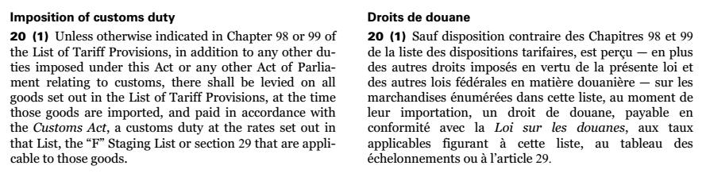
Customs Tariff – Schedule
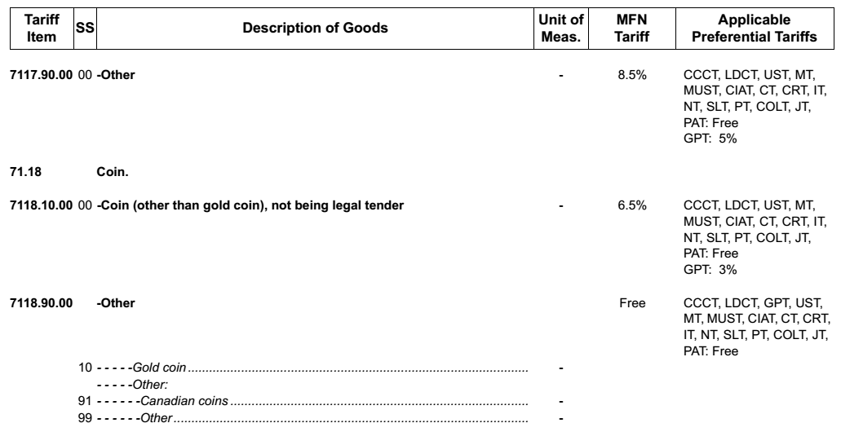

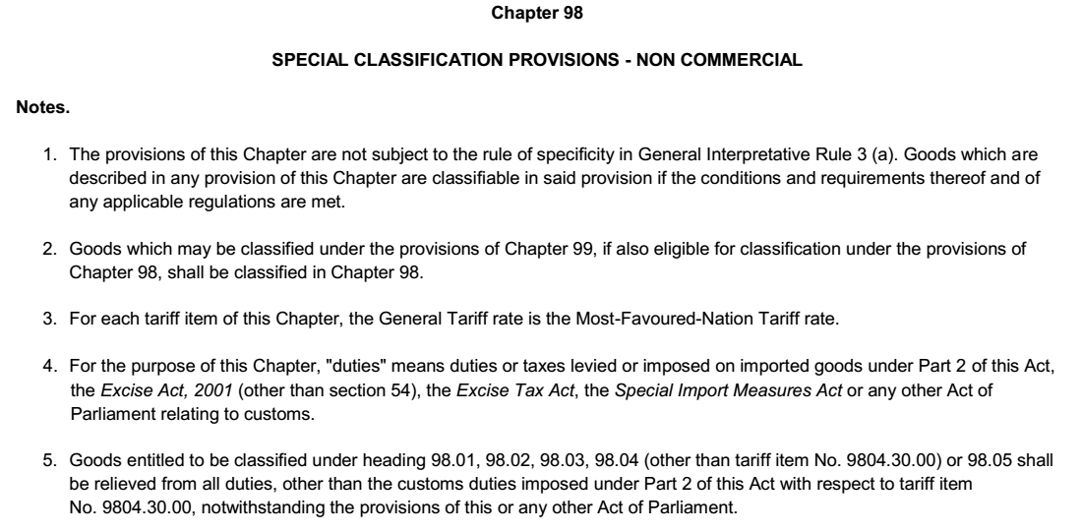
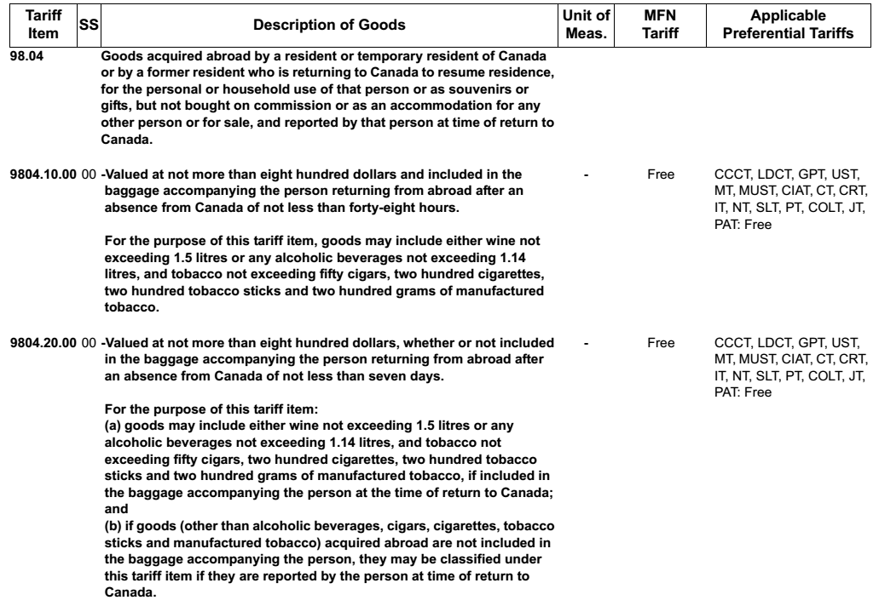
[...]
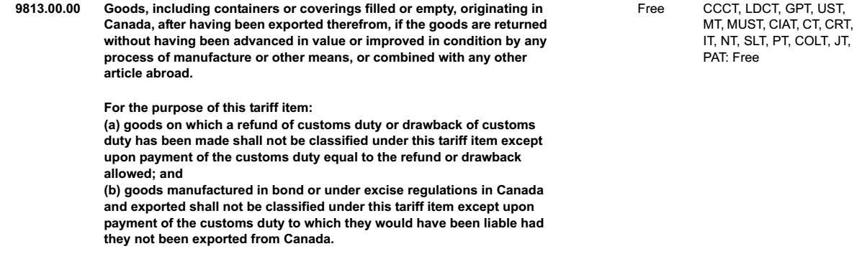
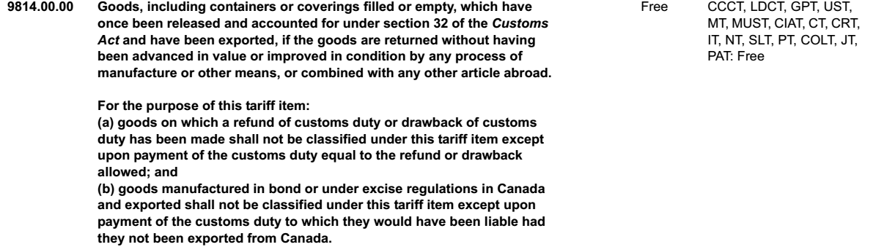

Currency Act, R.S.C. 1985, c. C-52
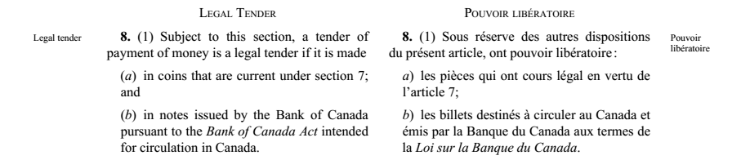
Customs Act, R.S.C. 1985, c. 1 (2nd Supp)

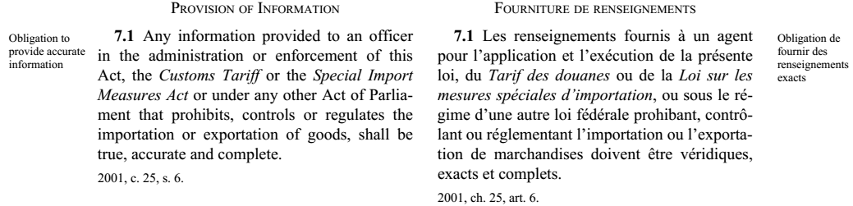

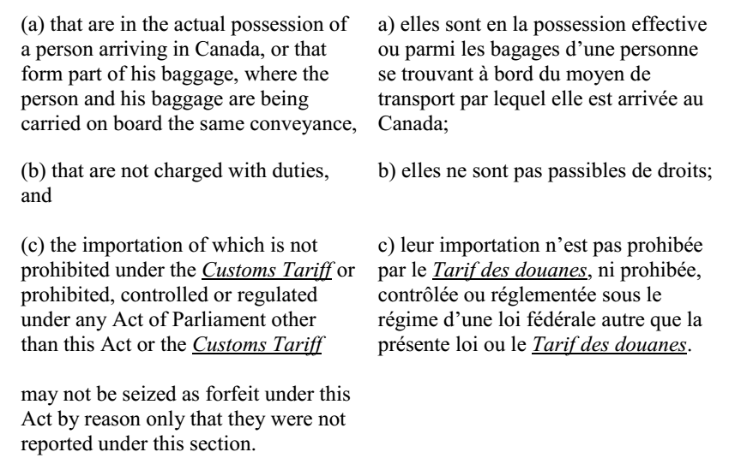
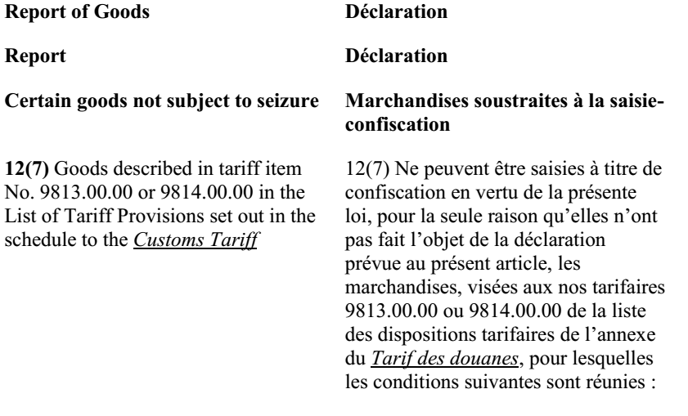
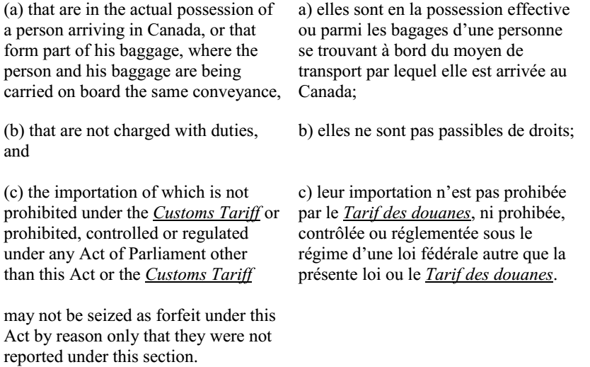

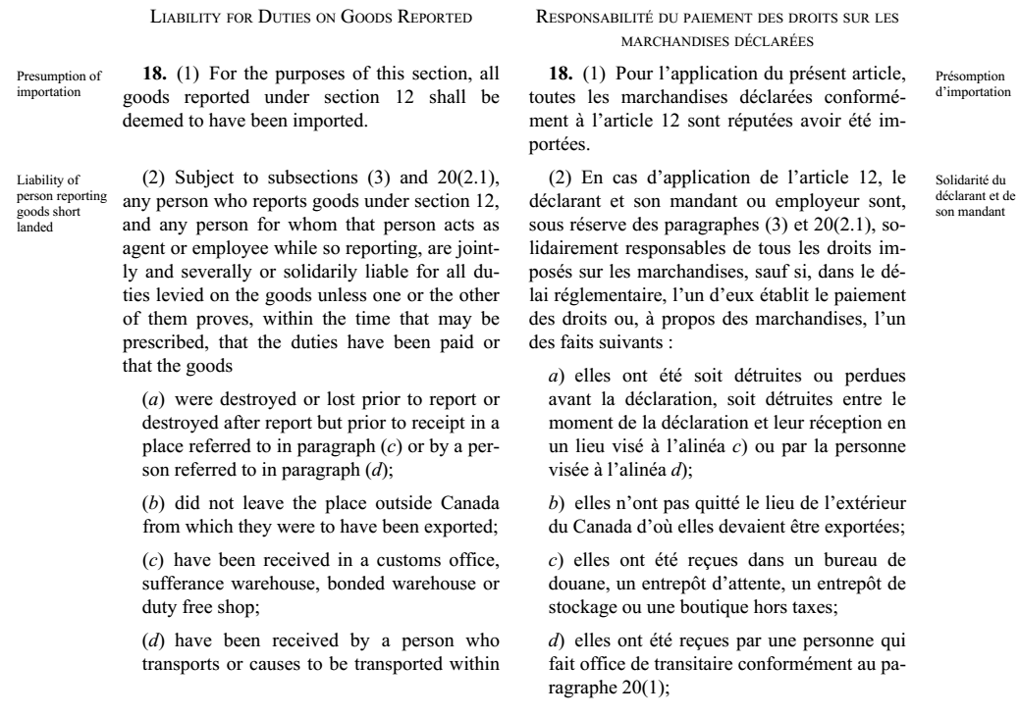

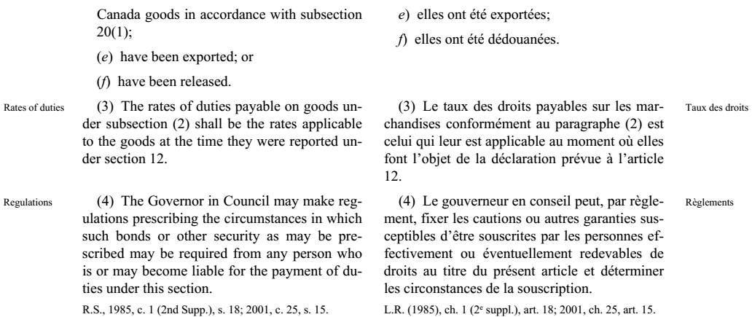
Federal Courts Act, R.S.C. 1985, c. F-7
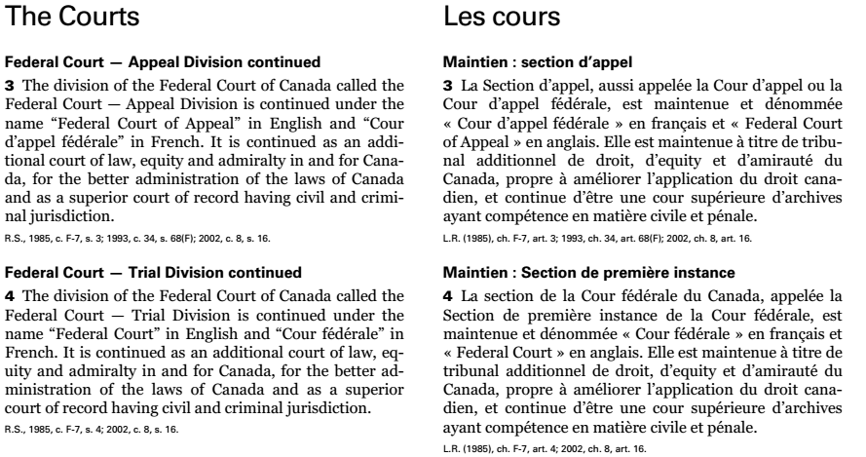

Documents Relied Upon

Information Bulletin – Precious Metals – Bullion and Coin
p1/3
Information Bulletin – Precious Metals – Bullion and Coin
p2/3
Information Bulletin – Precious Metals – Bullion and Coin
p3/3

Minister's Decision
P1/3
2/3
3/3

Proposed Amended Statement of Claim

